# TreeMap of the Sales and Proﬁts

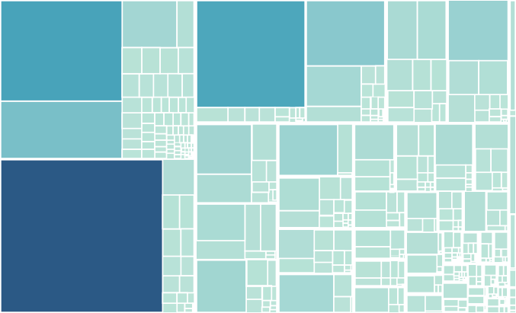

United States California

United States

United States

United States

United States New York New York City

HeatMap of the Sales and Proﬁts

# Packed Bubbles of the Sales and Proﬁts



Central

East

West

South

Region

Tree Map Proﬁt- Legend

0  62,037

Heat Map Sales-Legend

3

1,000

2,000

|  |
| --- |
|  |
|  |
|  |

3,000

3,538

Pie Chart-Legend

 Central  East  South West

Heat Map Proﬁt-Legend

-1,665 491

Sub-Catego.. Accessories Appliances Art

Binders Bookcases Chairs Envelopes Fasteners Furnishings Labels Paper Phones Storage Supplies Tables



Central East South West

   



  

   



   



Sub-Catego.. Accessories Appliances Art

Binders Bookcases Chairs Envelopes Fasteners Furnishings Labels Paper Phones Storage Supplies Tables

Region

Central East South West

Heat Map Proﬁt-Legend

-1,665 491

Heat Map Sales-Legend

3

1,000

2,000

3,000

3,538

Pie Chart-Legend

Central East South West

Central

East

West

South

Tree Map Proﬁt- Legend



United States California

Los Angeles

United States

United States Washington Seattle

United States Michigan

United States Indiana

United States California San Francisco

United States

United States

United States New York New York City

United States

0 62,037